# NAT Web

# Topology

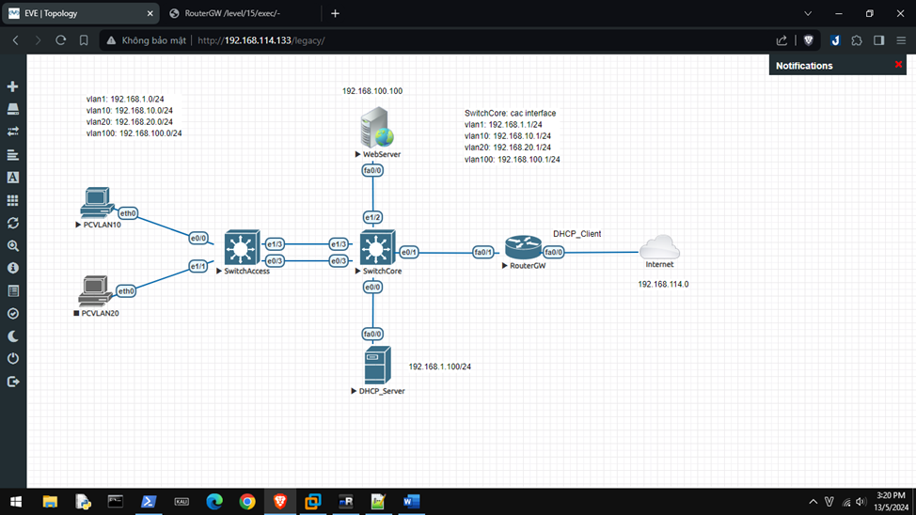

Cấu hình VTP, DHCP, Sub-Interface,… tương tự Lab 7.

Internet là VMNet8 (NAT)

# Cấu hình Web_Server

hostname Web_Server

ip name-server 8.8.8.8

username dtu privilege 15 secret 5 123

interface FastEthernet0/0

ip address 192.168.100.100 255.255.255.0

no shut

ip http server

ip http authentication local

ip http secure-server

ip domain-lookup

ip route 0.0.0.0 0.0.0.0 192.168.100.254

# 

# RouterGW

hostname RouterGW

ip name-server 8.8.8.8

interface FastEthernet0/0

ip address dhcp

ip nat outside

interface FastEthernet0/1

ip address 192.168.1.254 255.255.255.0

ip nat inside

interface FastEthernet0/1.10

encapsulation dot1Q 10

ip address 192.168.10.254 255.255.255.0

ip helper-address 192.168.1.100

interface FastEthernet0/1.20

encapsulation dot1Q 20

ip address 192.168.20.254 255.255.255.0

ip helper-address 192.168.1.100

interface FastEthernet0/1.100

encapsulation dot1Q 100

ip address 192.168.100.254 255.255.255.0

ip nat inside

access-list 1 permit 192.168.1.0 0.0.0.255

access-list 1 permit 192.168.10.0 0.0.0.255

access-list 1 permit 192.168.20.0 0.0.0.255

access-list 1 permit 192.168.100.0 0.0.0.255

ip nat inside source list 1 interface FastEthernet0/0 overload

ip nat inside source static tcp 192.168.100.100 80 192.168.114.147 80 extendable

# 

# Internet

Card mạng VMNet8 (NAT) là card 0.

